SCON

Ethio-Supply Chain Optimization Network
AI-Powered Integrated Supply Chain Network
Mobile Application • Web Platform • Global Network
1. ADMINISTRATION
Governance, verification, finance, AI control and platform management.
2. SUPPLIERS
Business management, products, inventory, prices, quotations and sales.
3. CUSTOMERS
Procurement, project requirements, supplier selection, orders and payments.
4. GUESTS
Public marketplace, product discovery, supplier directory and registration.
SHARED INTELLIGENCE & INTEGRATION LAYER
AI • GPS & GIS • Pricing • Transport • Payments • Analytics • Notifications • Security
The platform has four main user menus. Transporters should have a dedicated operational dashboard and menu, accessible to verified transport companies and integrated with customer orders and supplier dispatches.

2. ADMINISTRATION MENU

Administration – Enterprise Control Centre

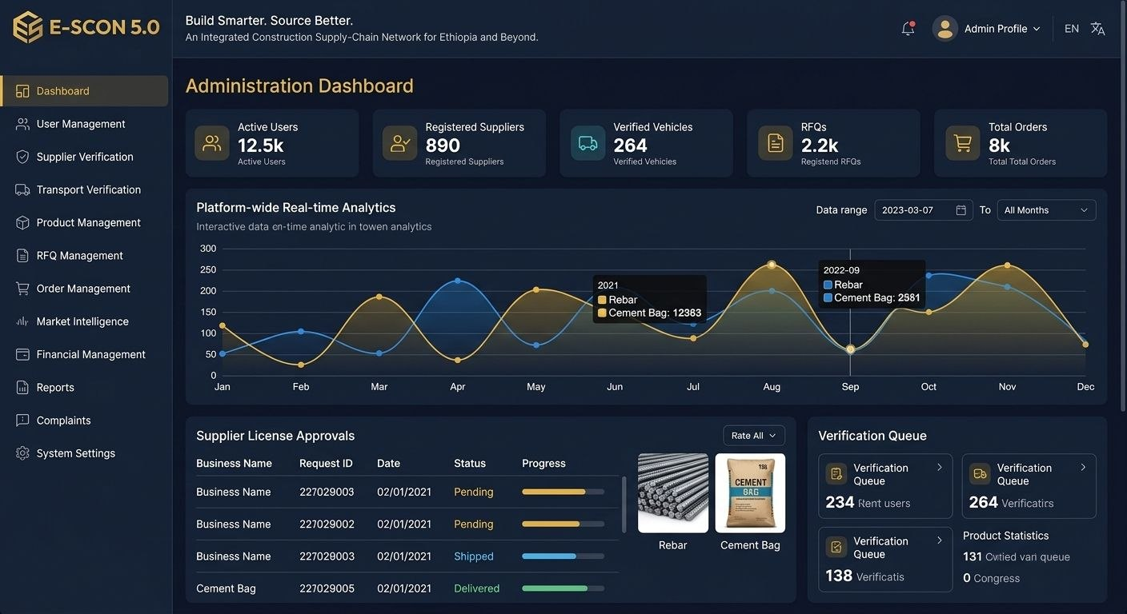
Administration submenu and task descriptions
No. | Feature / submenu | Main tasks and detailed description
1 | Admin Dashboard | View total registered users, active suppliers, customers, transporters, products, orders, revenue and system activity. Monitor daily, weekly and monthly performance.
2 | User Management | Register, approve, suspend, update and deactivate user accounts. Assign roles and permissions. Review login activity and account history.
3 | Supplier Management | Verify supplier identity, business licences, addresses, warehouses and products. Approve, reject or suspend supplier accounts.
4 | Customer Management | Manage contractor, company and individual customer profiles. Verify business information, manage account status and resolve customer issues.
5 | Transporter Management | Verify transport companies, vehicles, driver licences, vehicle capacities and service areas. Monitor transporter performance.
6 | Product & Category Management | Create and organize categories such as cement, sand, aggregate, steel, HCB and other products. Review product descriptions, specifications, units and listings.
7 | Price Management | Monitor supplier prices, price changes, historical records and unusual pricing. Set platform pricing rules where authorized.
8 | Order Management | Monitor customer orders, supplier confirmation, proformas, dispatch, delivery and completion. Investigate cancelled or delayed orders.
9 | RFQ & Quotation Management | Monitor requests for quotations, supplier responses, quotation validity, price comparisons and procurement status.
10 | Logistics Management | Monitor delivery requests, transport quotations, GPS tracking, route distances, estimated delivery times and proof of delivery.
11 | Finance & Payments | Monitor transaction records, payment confirmations, commissions, refunds, supplier settlements and financial reconciliation.
12 | AI Intelligence Centre | Monitor AI recommendations, price forecasts, demand predictions, supplier matching, route optimization and model performance.
13 | Reports & Analytics | Generate operational, financial, procurement, supplier, customer and logistics reports. Export approved reports.
14 | Complaints & Disputes | Receive, investigate and resolve complaints related to products, delivery, payments, quotations and service quality.
15 | Notifications & Communication | Send platform announcements, account notifications, order alerts, system updates and targeted messages.
16 | Security & Audit | Manage access permissions, MFA policies, login records, suspicious activity, audit logs and security incidents.
17 | Platform Settings | Configure language, currency, tax, units, locations, product categories, business rules and country settings.
18 | Technical Monitoring | Monitor system health, API availability, integration errors, backups, database performance and service interruptions.

Main administration tasks
Approve and verify new suppliers, customers and transporters.
Control user access and platform permissions.
Monitor every order from quotation to delivery.
Review price and transport-cost information.
Monitor payment records and financial transactions.
Resolve complaints and business disputes
Generate performance reports.
Manage platform security and technical operations
Monitor AI recommendations and approve sensitive automated actions.

3. SUPPLIERS MENU

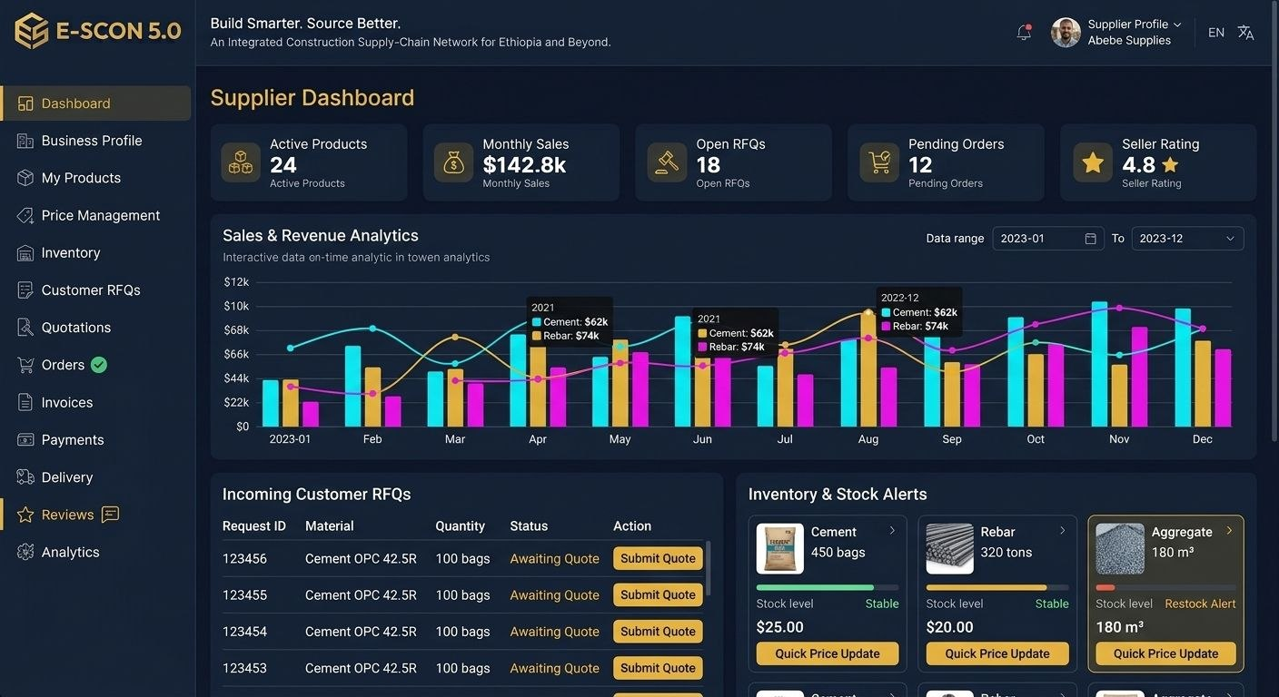Supplier submenu and task descriptions
No. | Feature / submenu | Main tasks and detailed description
1 | Supplier Dashboard | View total products, available stock, pending orders, new RFQs, sales, quotations, revenue and customer activity.
2 | Business Profile | Enter company name, registration details, business licence, contact information, business type and company description.
3 | Verification Centre | Upload business licences, tax documents and required certificates. Track verification status and respond to administrator requests.
4 | Location & Warehouse | Register warehouse locations using GPS. Add warehouse addresses, service areas, operating hours and available delivery coverage.
5 | Product Management | Add, edit, update and remove products. Include product name, category, grade, specifications, images, unit, description and availability.
6 | Inventory Management | Update available stock, reserved stock, minimum stock levels, warehouse quantities and stock movements. Receive low-stock alerts.
7 | Price Management | Set product prices, unit prices, bulk discounts, minimum order quantities and price validity dates. Maintain price history.
8 | RFQ Management | Receive customer requests for quotations. Review required materials, quantities, delivery locations and requested dates.
9 | Quotation Management | Prepare quotations showing product specifications, quantity, unit price, subtotal, taxes, delivery charges, validity and total amount.
10 | Order Management | Accept, reject or update orders. Confirm stock, prepare products, update order status and coordinate dispatch.
11 | Proforma & Invoicing | Generate proforma invoices, commercial invoices, receipts and transaction documents.
12 | Customer Management | View customer enquiries, purchasing history, reviews and communication records.
13 | Delivery Coordination | Request transport services, share collection details, coordinate loading and track delivery progress.
14 | Sales & Revenue Analytics | Review sales volume, revenue, best-selling products, quotation acceptance and customer retention.
15 | AI Business Assistant | Receive demand forecasts, stock recommendations, pricing insights and suggestions for potential customers.
16 | Messages & Notifications | Receive customer enquiries, new RFQs, order confirmations, payment updates and administrative notices.
17 | Supplier Performance | View customer ratings, fulfilment rates, delivery reliability, quotation response time and verified business status.
18 | International Business | Manage international enquiries, export product information, commercial documents and cross-border sourcing requests when enabled.

Example: Supplier product registration
Product registration – Sample screen
REBAR GRADE 60 (12mm)
Category: Construction Materials

166.75 Birr/kg
Product field | Example
Product name | Rebar Grade 60 (12mm)
Unit | kg
Unit price | 166.75 Birr
Stock quantity | 20,000 kg
Supplier location | CMC, Addis Ababa
Product status | Available
Delivery service | Available on request
Illustrative data, not a verified live supplier listing.

Main supplier tasks
Register and maintain a verified business profile.
Upload and update products.
Manage inventory and warehouse locations.
Set and update current product prices.
Receive and respond to customer RFQs.
Generate quotations and proforma invoices.
Confirm orders and coordinate transportation.
Track sales, payments and customer reviews.
Use AI to improve stock, pricing and sales decisions.

4. CUSTOMERS MENU
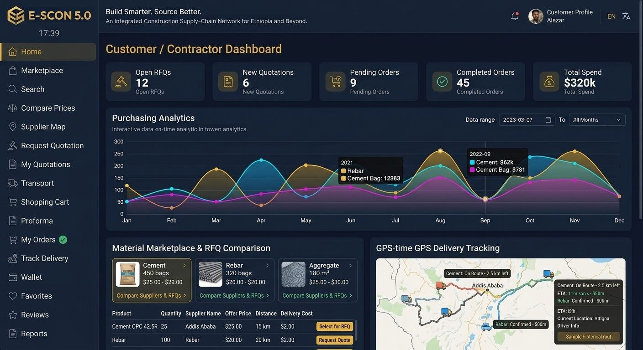

Customer submenu and task descriptions
No. | Feature / submenu | Main tasks and detailed description
1 | Customer Dashboard | View active projects, material requirements, pending quotations, current orders, deliveries, payments and purchasing history.
2 | Customer Profile | Manage customer name, company details, contact information, business documents and account settings.
3 | Project Management | Create projects, project budgets, construction sites, project managers and material procurement schedules.
4 | Site & GPS Location | Add construction-site locations using GPS or map selection. Save multiple delivery addresses and calculate supplier distances.
5 | Smart Product Search | Search by product name, category, specification, image or voice. Filter by grade, unit, price and availability.
6 | Supplier Discovery | Find verified suppliers by location, product availability, distance, rating, price and service coverage.
7 | Product Comparison | Compare product specifications, grades, unit prices, stock availability, supplier ratings and delivery conditions.
8 | AI Procurement Assistant | Recommend suitable suppliers, compare offers, identify cost-saving opportunities and help prepare procurement requests.
9 | Price Intelligence | View available prices, historical price movements and price alerts. Clearly identify the date and source of each price.
10 | Request for Quotation (RFQ) | Send one material request to multiple eligible suppliers. Specify quantity, technical requirements, delivery site and required date.
11 | Quotation Comparison | Compare supplier quotations, product prices, transport costs, delivery times, terms and total delivered costs.
12 | Shopping Cart | Add products, adjust quantities, calculate subtotals, review delivery charges and prepare the purchase.
13 | Proforma & Purchase Orders | Review supplier proformas, generate purchase orders and confirm procurement details.
14 | Payment Centre | View payment instructions, supported payment methods, payment confirmations, receipts and transaction history.
15 | Order Tracking | Monitor order acceptance, preparation, loading, dispatch, GPS tracking, estimated arrival and delivery completion.
16 | Delivery Management | Select delivery address, schedule delivery, review transport charges and confirm receipt of materials.
17 | Documents Centre | Store and access quotations, proformas, invoices, purchase orders, receipts and delivery documents.
18 | Reviews & Complaints | Rate suppliers and transporters, submit complaints, report product problems and track dispute resolution.
19 | Procurement Analytics | Monitor project expenditure, material quantities, price comparisons, supplier performance and procurement history.
20 | Notifications & Messages | Receive quotation updates, price alerts, order notifications, delivery information and supplier messages.

Customer purchase workflow – E-SCON integrated process

From product search to final delivery
Search for materials
Customer searches for cement, sand, aggregate, steel, HCB or another product.
Compare suppliers
E-SCON displays supplier location, product specifications, current listed price, stock and ratings.
Calculate transport cost
GPS/map integration calculates the supplier-to-site distance and estimates transport charges.
Compare quotations
Customer compares product cost, transport, taxes and delivery time.
Prepare proforma
Review quantities, unit prices, subtotal, VAT and delivery charges.
Confirm order and payment
Customer approves the order and uses an enabled payment method or agreed payment arrangement.
Track delivery
Monitor dispatch, vehicle location, estimated arrival and delivery confirmation.
Review and close
Confirm receipt, review the supplier and transporter, and retain transaction documents.

Example: Customer delivered-cost calculation
Suppose a customer orders 1,000 kg of Rebar Grade 60 (12mm).
Cost component | Example
Quantity | 1,000 kg
Unit price | 166.75 Birr/kg
Material subtotal | 166,750 Birr
VAT (15%, illustrative) | 25,012.50 Birr
Transport cost | 5,000 Birr
Grand total | 196,762.50 Birr
The platform should calculate each amount automatically from the approved supplier quotation and applicable tax and transport rules. The figures above are illustrative.
Expected result: Customers make informed purchasing decisions using verified information, supplier comparisons and transparent delivered-cost calculations.

5. GUEST MENU

Guests – Public Marketplace & Discovery

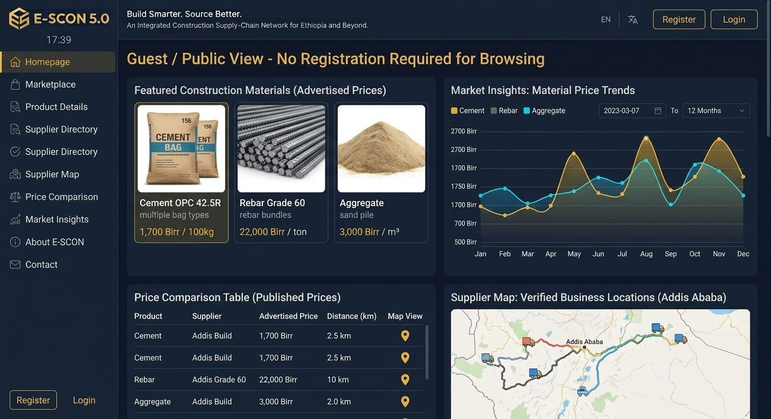

Guest submenu and task descriptions
No. | Feature / submenu | Main tasks and detailed description
1 | Home Page | Introduce E-SCON, explain the platform, display featured products, marketplace categories and main services.
2 | Public Marketplace | Browse publicly available products and material categories without accessing private account information.
3 | Product Catalogue | View permitted product images, descriptions, specifications, units and publicly displayed prices.
4 | Supplier Directory | Discover approved supplier businesses, public business profiles and service locations.
5 | Supplier Map | Explore supplier locations and public service coverage through an interactive map.
6 | Market Insights | View permitted market price trends, industry information and general supply-chain insights.
7 | Transport Services | Understand available delivery services, transport coverage and how delivery pricing is calculated.
8 | AI Search Preview | Use public product search and basic discovery recommendations without accessing confidential data.
9 | How E-SCON Works | View tutorials and explanations of product search, quotations, purchasing and delivery.
10 | About E-SCON | Learn about the platform's vision, mission, objectives, services and future international expansion.
11 | Language Settings | Select English, Amharic and other supported languages as they become available.
12 | Help & Support | Access frequently asked questions, user guides, support information and contact details.
13 | Register | Create a customer, supplier or transporter account.
14 | Sign In | Log in to an existing verified account and access role-specific functions.

Guest access rules
Publicly accessible | Requires registration
Public product catalogue | Add to cart and purchase
Public supplier directory | Submit RFQs
Public supplier locations | View private quotations
Public platform information | Access order history
Public market insights | Make payments
Help and tutorials | Manage business inventory
Expected result: Guests can understand and explore E-SCON before becoming registered customers, suppliers or transporters.
Feature | Main tasks
Transport Dashboard | Monitor delivery requests, active trips, completed trips and earnings.
Company Profile | Register transport business, service areas and business documents.
Vehicle Management | Register trucks, vehicle types, capacities and maintenance information.
Driver Management | Manage driver profiles, licences, availability and assignments.
Delivery Requests | Receive and accept customer or supplier delivery requests.
Transport Pricing | Set transport rates based on distance, load, vehicle and service conditions.
Route Management | Calculate routes, distances, estimated times and alternative routes.
GPS Tracking | Share vehicle location and delivery progress with authorized users.
Dispatch Management | Assign drivers and vehicles, schedule pickup and manage deliveries.
Proof of Delivery | Submit delivery confirmation, photographs, signatures and timestamps.
Financial Records | View transport quotations, invoices, earnings and payment status.
Performance Analytics | Monitor delivery reliability, vehicle utilization and operating costs.

7. Shared AI and integration features
These features connect the four menus and the transporter dashboard into one integrated network.
Shared system | Function | Connected menus
AI Supplier Matching | Recommends suitable suppliers based on product, price, distance and performance. | Customers, Suppliers, Administration
AI Price Intelligence | Analyzes available prices and historical price trends. | Customers, Suppliers, Administration
GPS & GIS Mapping | Locates suppliers, warehouses, customers and delivery sites. | All relevant roles
Smart Transport Cost | Calculates estimated transport costs from distance and rate rules. | Customers, Suppliers, Transporters
AI Demand Forecasting | Estimates future product demand using available historical data. | Suppliers, Administration
Smart Inventory | Supports stock monitoring and replenishment recommendations. | Suppliers, Administration
AI Procurement Assistant | Helps customers prepare and compare procurement requests. | Customers
Document Intelligence | Extracts information from approved invoices, quotations and business documents. | All relevant roles
Notifications | Communicates RFQs, orders, deliveries and account updates. | All relevant roles
Business Analytics | Produces operational and performance reports. | Administration, Suppliers, Customers, Transporters
AI recommendations must be based on available and appropriately authorized data. Prices, stock, routes and delivery times should be labelled with their source and update time. Payments, contracts and other sensitive decisions should remain subject to authorized human approval.

8. Complete E-SCON navigation structure
This is the recommended menu hierarchy for the web platform and mobile application.
E-SCON 5.0 MAIN MENU
Role-based access and navigation
1. ADMINISTRATION
Dashboard • Users • Suppliers • Customers • Transporters • Products • Prices • Orders • Finance • AI • Reports • Security • Settings
2. SUPPLIERS
Dashboard • Business Profile • Verification • Locations • Products • Inventory • Prices • RFQs • Quotations • Orders • Invoices • Analytics
3. CUSTOMERS
Dashboard • Profile • Projects • Site GPS • Search • Suppliers • Compare • RFQs • Cart • Proforma • Payments • Orders • Tracking • Reviews
4. GUESTS
Home • Marketplace • Catalogue • Supplier Directory • Map • Market Insights • About • Help • Register • Sign In
5. TRANSPORTERS
Dashboard • Company • Vehicles • Drivers • Requests • Pricing • Routes • GPS • Dispatch • Delivery • Earnings • Analytics
CONNECTED PLATFORM SERVICES
AI Intelligence • GPS/GIS • Pricing Engine • Logistics Engine • Payment Gateway • Data Analytics • Security • APIs

9. Recommended design standards for every menu
Design element | Required standard
Interface | Clean, modern, professional and consistent
Branding | E-SCON wordmark and unified visual identity
Colour | Deep navy, professional blue, white and restrained gold
Typography | Clear, readable and consistent
Navigation | Role-specific menus and clear page hierarchy
Dashboard | Useful KPIs, recent activity, alerts and quick actions
Data tables | Search, filter, sort, pagination and export permissions
Forms | Clear labels, validation, required fields and helpful error messages
Mobile design | Responsive layouts and touch-friendly controls
Languages | English, Amharic and expandable multilingual support
Security | Role-based permissions, secure sessions, audit trails and MFA options
Accessibility | Keyboard support, readable contrast and accessible controls
Notifications | Clear alerts for important events and pending tasks
Reliability | Backups, error monitoring and recovery procedures

10. Development priorities
To develop this successfully, the platform should be delivered in stages rather than attempting to implement every advanced feature at once.
Phase 1 – Core platform
Create registration, login, role permissions, administration, supplier profiles, customer profiles, product catalogue and basic marketplace.
Phase 2 – Procurement and transactions
Build RFQs, quotations, supplier comparison, shopping cart, proforma, orders, payment records and invoices.
Phase 3 – Logistics and GPS
Implement transporter accounts, vehicle management, GPS locations, distance calculation, transport pricing and delivery tracking.
Phase 4 – AI intelligence
Introduce supplier matching, price analysis, demand forecasting, inventory recommendations and route optimization.
Phase 5 – International network
Add multi-country operations, currencies, languages, international suppliers, partner APIs and cross-border trade workflows.

